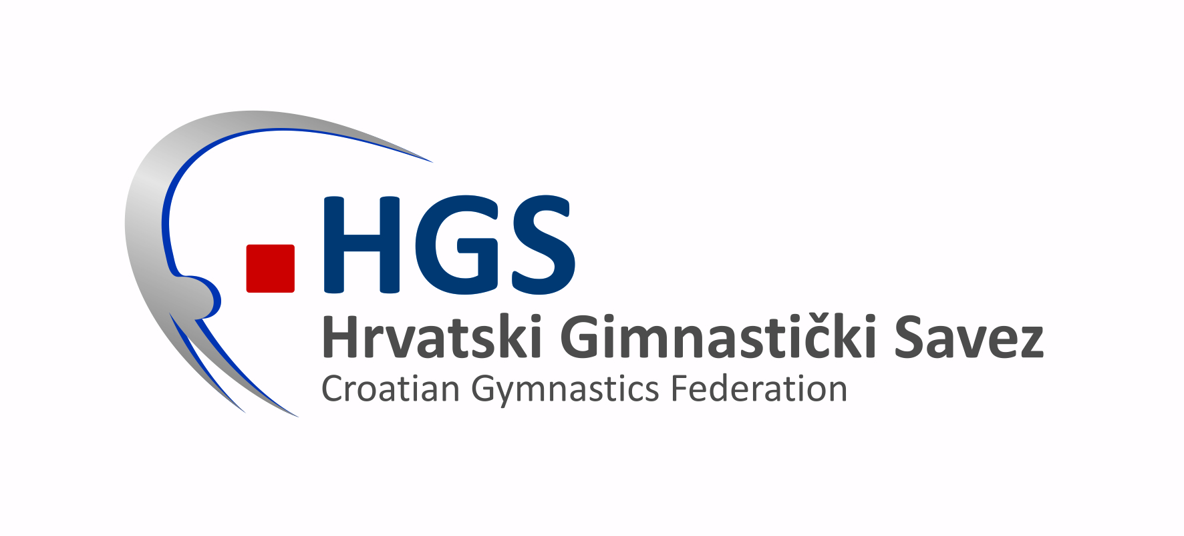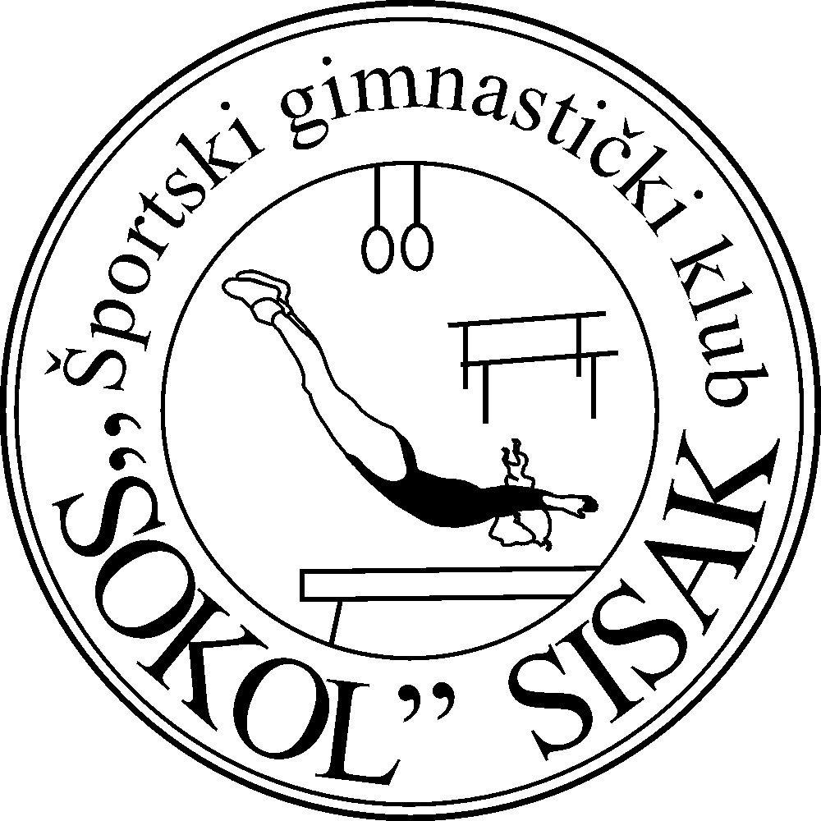

DEFINITIVE FORM

deadline 30th May 2014
Croatian Gymnastics Federation
Trg Krešimira Ćosića 11, Zagreb, Croatia
Tel: + 385 1 30 123 24 Fax: + 385 1 30 910 03
e-mail: hrvatski.gim.savez@gmail.com

Open Championship of Sisak

Function | Number of persons
MAG GYM
WAG GYM
MAG JUDGE
WAG JUDGE
MAG COACH
WAG COACH
OTHERS
TOTAL

2nd International Team Competition

Function | Number of persons
MAG GYM
WAG GYM
MAG JUDGE
WAG JUDGE
MAG COACH
WAG COACH
OTHERS
TOTAL

