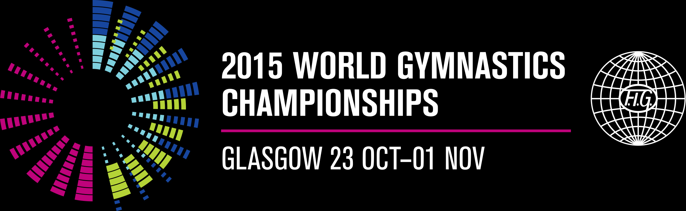

Monday 16 February 2015 for immediate use

IT’S NEXT STOP GLASGOW FOR THE WORLD’S TOP GYMNASTS

With the gymnastics season in full swing, Glasgow, Scotland is looking forward to welcoming the world’s top gymnasts for the FIG 2015 World Artistic Gymnastics Championships in just 250 days’ time.

It may only be just over six months since the final curtain came down on the Glasgow 2014 Commonwealth Games, but the city is already looking forward to hosting one of the world’s largest single sport events and showcasing the city to an even wider global audience.

Glasgow enjoys a longstanding relationship with gymnastics, staging its first ever Grand Prix event in 1997 and annually thereafter. April 2011 brought the newly revamped format of the FIG World Cup to Glasgow – now one of only four cities in the world to host the All-around World Cup, which has enjoyed sell-out attendances from 2011 to 2014.

Glasgow is now proud to be hosting the FIG World Artistic Gymnastics Championships, which will take place at the SSE Hydro from 23rd October – 1st November this year and it is already promising to be one of the biggest sporting events ever staged in the UK.

The 10-day event will bring together more than 500 gymnasts from up to 80 nations all vying to be crowned 2015 world champion. Just to raise the stakes and test the gymnasts even further, the event will also play a key role in Olympic qualification, with the opportunity to secure places for Rio 2016.

The best gymnasts in the world will go head to head in team and individual all-around competitions as well as apparatus finals, in front of capacity crowds at Glasgow's iconic SSE Hydro - now rated the second best entertainment venue in the world.

The event will be extensively broadcast on the BBC and it is also anticipated that it will be shown on all five continents via distribution by the FIG broadcast partners.

The FIG Championships are being delivered through a partnership between FIG, British Gymnastics and Glasgow Life on behalf of Glasgow City Council with significant support from EventScotland and UK Sport.

They form part of UK Sport’s National Lottery funded major events programme to support athletes with their preparation and qualification for Rio 2016.

And with just 250 days to go until the gymnasts take to the arena, organisers are focused on delivering the best ever World Gymnastics Championships for gymnasts and spectators alike.

Councillor Gordon Matheson, Leader of Glasgow City Council, said: "Glasgow's Commonwealth Games will live long in the memory. They were universally acclaimed as the best ever and showed the world why Glasgow is rightly regarded as one of the world's top 10 sporting cities.

“Glasgow 2014 demonstrated that not only do we know how to deliver a world-class event, but we are also a welcoming and friendly city. People make Glasgow, and while we welcomed the Commonwealth to our city in 2014, this year we will welcome the world.

“2015 is already being referred to as Glasgow's Year of Sport, with the World Gymnastics Championships undoubtedly the stand-out event. We are looking forward to welcoming the gymnastics family to Glasgow this October when we aim to deliver the best ever World Championships and put on a show that will once again wow the world."

Jane Allen, British Gymnastics Chief Executive Officer, said: “The excitement is definitely growing as we get closer to what promises to be the greatest World Gymnastics Championships ever. Glasgow has repeatedly proved that it is a world class host of world class events and we can’t wait to welcome the best gymnasts on the planet to the SSE Hydro in October.

“The 2015 World Gymnastics Championships are hugely important for our gymnasts and we expect the home crowd to play a significant role in inspiring them all to excel as we look to secure places at the Olympic Games.”

Paul Bush OBE, Chief Operating Officer, EventScotland said: Paul Bush OBE, Chief Operating Officer for EventScotland said: “The World Gymnastics Championships will undoubtedly be one of the sporting highlights of 2015 in Scotland and preparations are well underway to ensure it is a huge success. Scotland is the perfect stage for events and with the world’s top athletes competing in one of the world’s most spectacular arenas, fans are certainly in for a treat.”

Simon Morton, Director of Major Events and International Relations at UK Sport, said:
“The World Gymnastics Championships will give thousands of people the opportunity to witness world class sport first hand and also makes excellent use of a Glasgow 2014 Commonwealth Games venue.
“This is a crucial event as Great Britain’s athletes strive to qualify for Rio 2016 and we know they are inspired by a passionate home crowd. I would encourage people to go along and back our athletes on their road to Rio.”
Ticket sales have been buoyant since their release last summer and the wider gymnastics family is urged to book soon to avoid disappointment. We look forward to welcoming gymnasts’ family and friends as well as travelling gymnastics supporters to Glasgow and exclusive Fan Packages are available.

For the first time ever in the history of the World Gymnastics Championships, we’re offering an unrivalled VIP spectator experience! Working with leading sports travel experts CSE, packages offer a four or six night stay in the city in official Championships hotels and VIP extras that will make a visit to the 2015 World Championships an unforgettable experience.

You will enjoy the action from a unique perspective, sitting in the very best seats in the SSE Hydro – located on the arena floor, right next to the gymnasts. Spectators have never before been able to watch from such a unique position, usually only reserved for the stars of the sport and officials. To find out more please e-mail WGC2015fanpackage@cseplc.com or www.2015worldgymnastics.com

- ENDS -

NOTES TO EDITORS

Tickets can be booked:
Online: www.2015worldgymnastics.com
On the phone: 0844 481 1221 from within the UK (or +44 141 564 4201 internationally)
In person: ticketSOUP box office, SECC, Exhibition Way, Glasgow, G2 8YW.

Media accreditation is now open until 2nd October 2015. Members of the media who wish to cover these events must register via the online media management tool for international Gymnastics events at https://media.fig-gymnastics.com eFor other media enquiries please contact media@2015worldgymnastics.com

Event organisation
The FIG World Artistic Gymnastics Championships are being delivered through a partnership between FIG, British Gymnastics and Glasgow Life on behalf of Glasgow City Council with significant support from EventScotland and UK Sport.

Glasgow Life
Glasgow Life was established in 2007 to deliver cultural and leisure services on behalf of, but not exclusively for, Glasgow City Council. It is a company limited by guarantee with charitable status. Glasgow Life delivers a diverse range of services and activities across the city, through a portfolio of 167 directly managed and leased facilities and outdoor recreation sites. Its services include Arts, Communities, Events, Libraries, Museums, Music, Sport and Young Glasgow. It works with communities and a range of partners across the public, private, and voluntary sectors in order to inspire Glasgow's citizens and visitors to lead richer and more active lives through culture and sport. For more information please visit www.glasgowlife.org.uk

British Gymnastics
British Gymnastics is proud to be the UK Governing Body for the sport of gymnastics. We exist to support, lead and inspire all those involved or interested in gymnastics; from creating new programmes and activities at grass roots to helping the development of top-level talent and delivering world-class events across the UK. For more information please visit www.british-gymnastics.org Follow British Gymnastics on Twitter @britgymnastics.

International Gymnastics Federation (FIG)
The International Gymnastics Federation is the governing body for gymnastics worldwide. It is the oldest established international sports federation and has participated in the Olympic Games since their revival in 1896. The FIG governs seven disciplines: Gymnastics for All, Men's Artistic, Women's Artistic, Rhythmic, Trampoline, Aerobic and Acrobatic. It counts 142 national member federations and boasts a 28-person staff at its international seat in Lausanne (SUI), host city of the International Olympic Committee (IOC).

EventScotland
EventScotland is working to make Scotland the perfect stage for events. By developing an exciting portfolio of sporting and cultural events EventScotland is helping to raise Scotland’s international profile and boost the economy by attracting more visitors. For further information about EventScotland, its funding programmes and latest event news visit www.EventScotland.org. Follow EventScotland on Twitter @EventScotNews. EventScotland is part of VisitScotland, the national tourism organisation which markets Scotland as a tourism destination across the world, gives support to the tourism industry and brings sustainable tourism growth to Scotland.

UK Sport
UK Sport is the nation’s high performance sports agency responsible for the strategic investment of around £350million of National Lottery and Exchequer funding in Olympic and Paralympic sports preparing for Rio 2016 and beyond.

UK Sport’s major events programme will invest £27million of National Lottery funding to support the bidding and staging costs of major events on home soil, as well as providing specialist support to organisers. Events are supported for their likely performance impact on GB athletes’ preparation and qualification on the road to Rio 2016 and also to maximise the wider sporting, social, cultural, economic and environmental benefits.

FOR FURTHER INFORMATION PLEASE CONTACT:
Katriona Bush, PR & Media Manager, 2015 World Gymnastics Championships
Mobile: +44 7971 782662
Email: kbush@bshsport.demon.co.uk

